**A Personalized Cut-off Predictor And College Recommender for Engineering Admissions**

A Synopsis Submitted in Partial Fulfillment of the Requirements

for the Degree of

**Bachelor In Technology**

Majoring in

**Computer Science and Technology**

Submitted by

**09 - Twinkle Bothara**

**10 - Rashi Chaturvedi**

**14 - Shruti Chavan**



**DEPARTMENT OF COMPUTER SCIENCE & TECHNOLOGY**

**USHA MITTAL INSTITUTE OF TECHNOLOGY**

**S.N.D.T Women’s University, Mumbai**

July, 2022

**CERTIFICATE**

This is to certify that Twinkle Bothara (09), Rashi Chaturvedi (10) and Shruti Chavan (14) have successfully completed PHASE-1 work on A Personalized Cut-off Predictor And College Recommender for Engineering Admissions in the partial fulfillment for the bachelor’s degree in Computer Science and Technology during the year 2022-2023 as prescribed by SNDT Women’s University.

**GUIDE**   **HEAD OF THE DEPARTMENT**

Prof N. GAWAI PROF. KUMUD WASNIK

### 

### 

### 

### **PRINCIPAL**

DR. SHIKHA NEMA

**EXAMINAR 1 EXAMINAR 2**

INTRODUCTION:

In our digital world, we can see that every facilities are available online, one of which is admission process. Students have to fill the online CAP round forms after their JEE and MH-CEt exams to get admitted into the colleges. So, it is necessary to have subsequent knowledge about colleges. But many times, students make mistakes in their preference list of colleges because of various reasons like inaccurate analysis of colleges, lack of knowledge, and apprehensive prediction. Later, they end up regretting the same after allotment. Our application addresses this issue of the student admission community.

After completion of high school or diploma, students will take admission in different Engineering colleges. Before taking admission, they faced many problems. In Maharashtra there are around 110 engineering courses wherein throughout every year approximately 90,000 to 1.5 lakhs students pass out. In addition, there are only 540 engineering colleges. Students and their parents are concerned about various queries related to the CAP round and filling list of colleges to apply in. Students get confused when selecting a good engineering college. Percentile, Rank, reservation, category, preferred branches, preferred district, and preferred colleges are taken as input and the preference list, on thorough analysis of the last four year’s cut-off data is generated.

In this paper, an attempt has been made to develop an automated web application prediction model for a college admission system which can be used to make a wise choice of college before allotment and predict the cutoff for every college . The system will uses the historical data of the different colleges, and using this data predict the most probable college for students. It will use machine learning algorithms, data analysis algorithms and techniques. As a machine learning problem, for training data, the system reads an internal database for college cut-off. User can predict the colleges within his/her range rather than waiting for decision.

PROBLEM STATEMENT:

The college recommendation system assumes a significant role as college choice requires a great deal of study of the quantity of variables according to the future perspective. Looking for a decent university is a tough job for a high schooler who needs to seek after his/her graduate studies. These students look for different angles like college campus, teaching staffs, extracurricular exercises in college, foundation of a college, and so on, even the surveys of college is looked to get additional affirmation about the subtleties. Our personalized college recommender and cut-off predictor will prescribe great colleges to a graduate depending on his/her decision of field,top evaluations, area and past rate.

In today’s world, it is increasingly important for students to be able to find the best colleges for their individual strengths and abilities. In fact, the admission process for many colleges has become so competitive that it comes down to how well they perform in school and on JEE and MH-CET tests. In past students need to make a handwritten or excel list for every MH-CET CAP round and select the colleges and rank them according to their cutoff (which usually changes every year) and also requires the student to read and reread each college’s cutoff list. Thus, by using personalized college recommender and cutoff predictor it will be significant as it will diminish the manual work and robotize this with the assistance of software.

Here, we are trying to design a model for developing a web application that serves as an extra and efficient online helpdesk capable of providing a 24/7 service for students in need of guidance to choose their career stream. It will be capable of proving acute services on single search option where students will get a proper list of campuses in proper rank based format based on their JEE or MHT-CET scores. Our approach will be designed to help less tech-savvy people by offering them a familiar environment and using a conversational agent to ease and guide their interactions. The proposed model will be validated by implementing a chatbot that will provide textual-based communications and uses state-of-the-art technology. This web application will then be tested with the help of students and teachers from the engineering degree sector.

LITERATURE SURVEY:

| Sr. No | Author | Paper | Description |
| --- | --- | --- | --- |
| 1. | Prof. Vishal R. Shinde, Miss. Anagha Bagul, Mr. Amit Gupta, Miss. Sneha Javeri | International Journal for Research in Engineering Application & Management (IJREAM) | 1. Explains a system presenting college FAQs chatbot that answers the queries of the users that are related to the college. 2. Developed in Python 3. Uses different APIs to get information from the database/corpus by using NLTK (Natural Language Tool Kit) |
| 2. | Naveen Kumar M, Linga Chandar P C, Venkatesh Prasad A, Sumangali K | IEEE Dec 2016, International Conference on Computational Intelligence and Computing Research (ICCIC) | 1. This is a system that has two different modules.   i) Rule based   * Dependent on rules and conditions. * Not reliable for all the cases.   ii) AI Based   * The system is trained based on natural language processing (NLP) with the data sets, which are conversion dialogs, to extract the combination of conversation, including intent, context, an entity. |
| 3. | B. R. Ranoliya, N. Raghuwanshi, and S. Singh | International Conference on Advances in Computing, Communications, and Informatics (ICACCI) | 1. The system breaks down the user sentence into intent and an entity. 2. The system uses a heuristic approach to deliver the suitable response. 3. The system uses pattern matching to classify the text and produce a suitable or best response for the clients. |
| 4. | P. R. Telang, A. K. Kali, M. Vukovic, R. Pandita and M. P. Singh | IEEE Internet Computing, vol. 22 | 1. Android based system. 2. System for visually weakened people 3. This system can be easily launched by using Google Voice Search. 4. The system makes use of two types of resources mediawiki API, AB library. 5. This method also uses pattern matching technique. |
| 5. | Emil Babu, Geethu Wilson, Msc Scholar, Assistant Professor | International Journal of Creative Research Thoughts (IJCRT) | 1. Android based system. 2. This paper focuses on automating the process of communication by use of chat-bot 3. This system attempts to create a chat-bot using Artificial Intelligence Markup Language and using various algorithms such as Keyword Matching. |
| 6. | Dr. Arunakumari B.N, Vishnu Sastry H.K, Sheetal Neeraj, Shashidhar R | Elementary Education Online | 1. The system is made with python machine learning libraries i.e. panda and numpy. 2. To deploy the web application worldwide, Heroku is used. 3. The candidate obtains a rough idea regarding the seat he or she   is likely to get depending on his or her rank and category. |
| 7. | Varsha Powar, Sheetal Girase, Debajyoti Mukhopadhyay, Anuja Jadhav, Shweta Khude, Shital Mandlik | 2017 International Conference on Advances in Computing, Communication and Control (ICAC3), IEEE Xplore: 19 March 2018 | 1. System provides a recommendation system which generates the user interested colleges list. 2. The college list is stored in the dataset which calculates the accuracy and precision of the system. 3. The students can give feedback for their performance. |
| 8. | Zhenrong Zhang | 2021 IEEE International Conference on Industrial Application of Artificial Intelligence (IAAI) | 1. The system is based on improved collaborative filtering technology. 2. The research includes two aspects:  * Designing the system framework * Personalized recommendation model  1. The system maintains a more accurate recommendation under any number of nearest neighbors, which proves the effectiveness of the system. |

EXISTING SYSTEM:

To find the cutoff of Engineering colleges students first need to visit DTE website and search for colleges which fits their criteria based on their reservations. Then students start searching for colleges matching their percentile and rank based on cutoff of CAP rounds.The list of colleges is also prepared manually.

After making the list of colleges, the existing system allows users to search for a particular college and shows the results based on the feedback given by alumni, or students currently studying in the colleges in the form of ratings.The information with its college info, courses, fees structure, placements, cutoffs of previous years, infrastructure, faculty is shown of one particular college. However some key points like placements with average salary and course fee structure will be available as they are not published every year by colleges. Also, one has to keep on searching for the desired colleges and check for cutoff of every college and write them down in sequential order.The complete process takes more that a day to complete and onc connot make any mistakes while preparing the list or their future can be in jeopardy.

Some system uses deep learning and natural language processing to analyze the previous search history of the users. The system then recommends similar colleges to students, this system tracks the user’s behavior to recommend colleges which align with their search interest.

PROPOSED SYSTEM:

Current system which is similar to our system provides solutions to the student by individually searching for the colleges. But other than a few prominent colleges and the ones in our vicinity, the students don’t have much idea about the rest. Also there is no such system available for where the students can get a general idea of the colleges they can get in all over Maharashtra in a single search. Our system aims in guiding a student for his career right through this.

The data for cutoff prediction will be collected from past four years of cutoff based on MH-CET exam cutoff list by DTE website and converted into excel sheet for evaluation. The average cutoff with the range of +/- 1.5% will be predicted by studying the data collected. The Cutoff will be calculated as per DTE format of three CAP rounds process.

The system will contain a basic text-based messaging system which will collect the tentative information about the students curriculum marks , his/her reservation, the branch of engineering he/she desires. The system will help students to get a list of colleges that are fitting their MHT-CET and JEE-Based marks in a proper higher to lower order Our aim is to develop a web application for graduate aspirants in order to help them in their admission process.

This project will help the high school students to get the list of colleges based on their JEE and MH-CET scores. The input provided by the students will be compared with past years’ college cut-offs and a list would be populated within the range of +5 and -5 of the student’s score. The generated list would be ordered based on the government and best rated college and cut-off. The rating of the college will be collected from various students across different colleges. Along with the cut-off the resulting list would be filtered based on other criteria's like caste information, region and minority provided by the student. Thus, the populated list can be used by the user to fill the B.E and B.Tech admission form hence reducing their stress of manually preparing the list or roaming everywhere to get information about admissions from their seniors. Also, this project will help the student to get into college based on their career’s perspective and also based on the field of interests.

FLOWCHART OF PROPOSED SYSTEM:

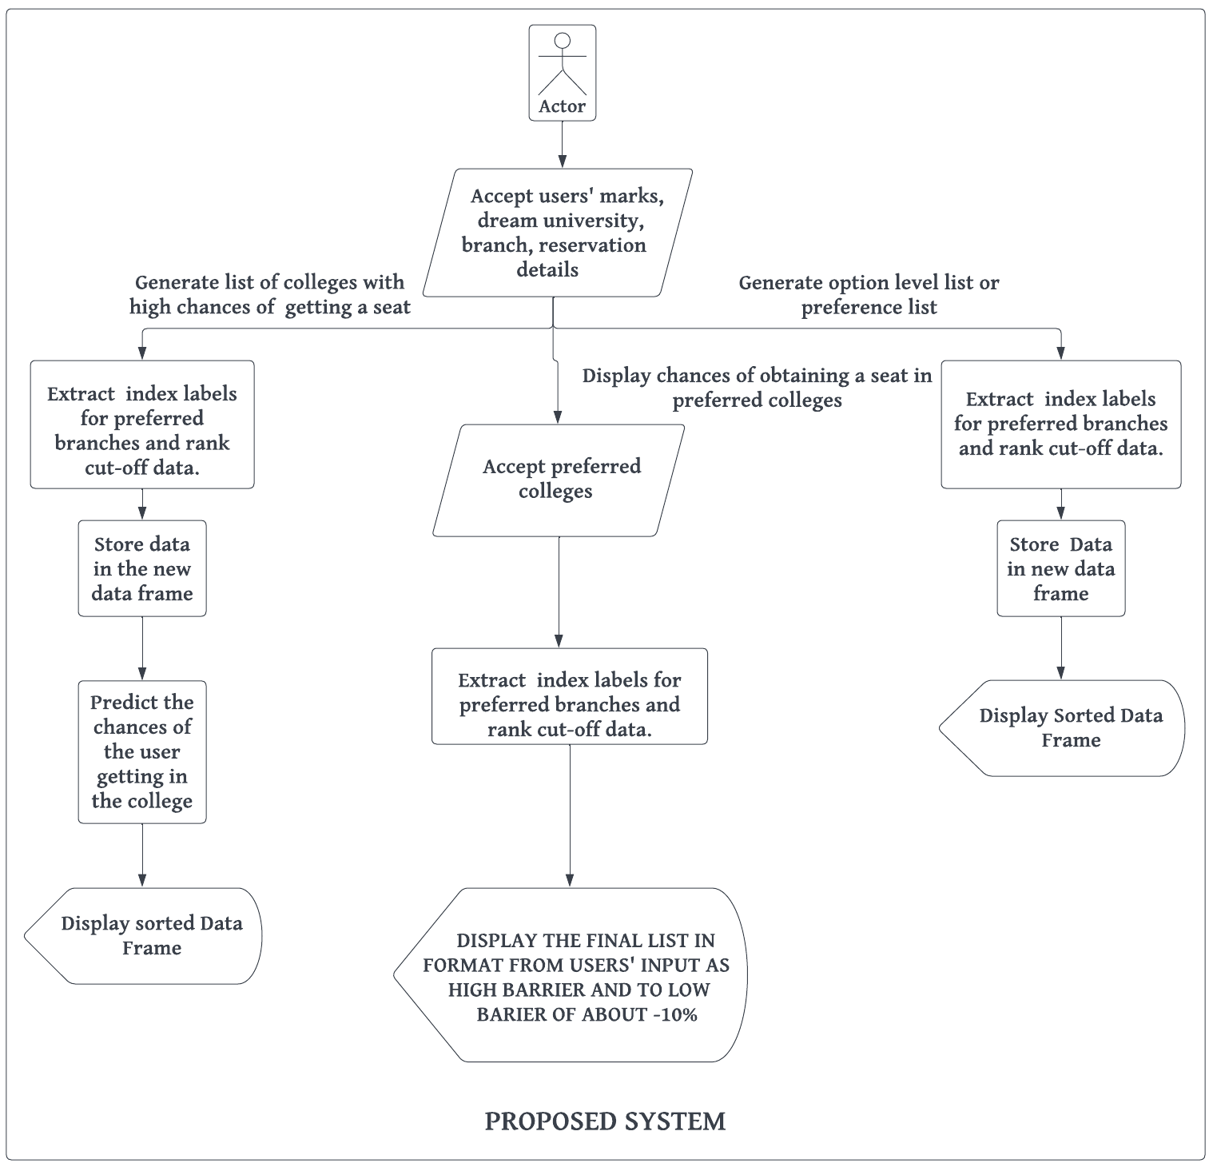

METHODOLOGY:

PROCESS:

In the first stage of the project we will start preparing the database which will contain the list of all Engineering colleges, college code, home university, branch code, branch name, reservation categories cut-off with all 3 CAP rounds held that year. The cut-off details will be taken from the official CET Cell website. In addition, the main database will consist of the average of previous four years’ percentile cut-off data. The cut-off database will consist of the ranks with respect to branch, college, and category. All the rest of the information of the colleges that we are going to put in the database will be based on student’s reviews. These reviews will be collected by us personally from some of the students of various colleges and by the way of google sheets.

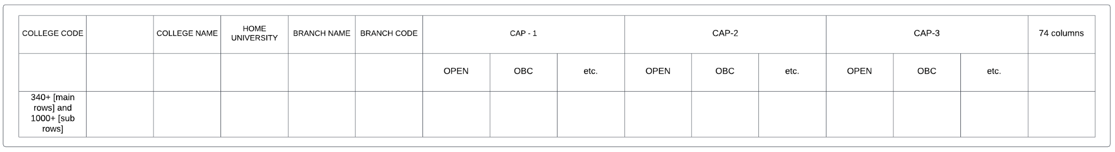

The second stage is to collect user's MH-CET rank and percentile, JEE rank and percentile, dream universities, branches if they want to opt for multiple branches for same college , their reservation, their high school percentage and the CAp round to apply for.The information will be collected using text based messaging.

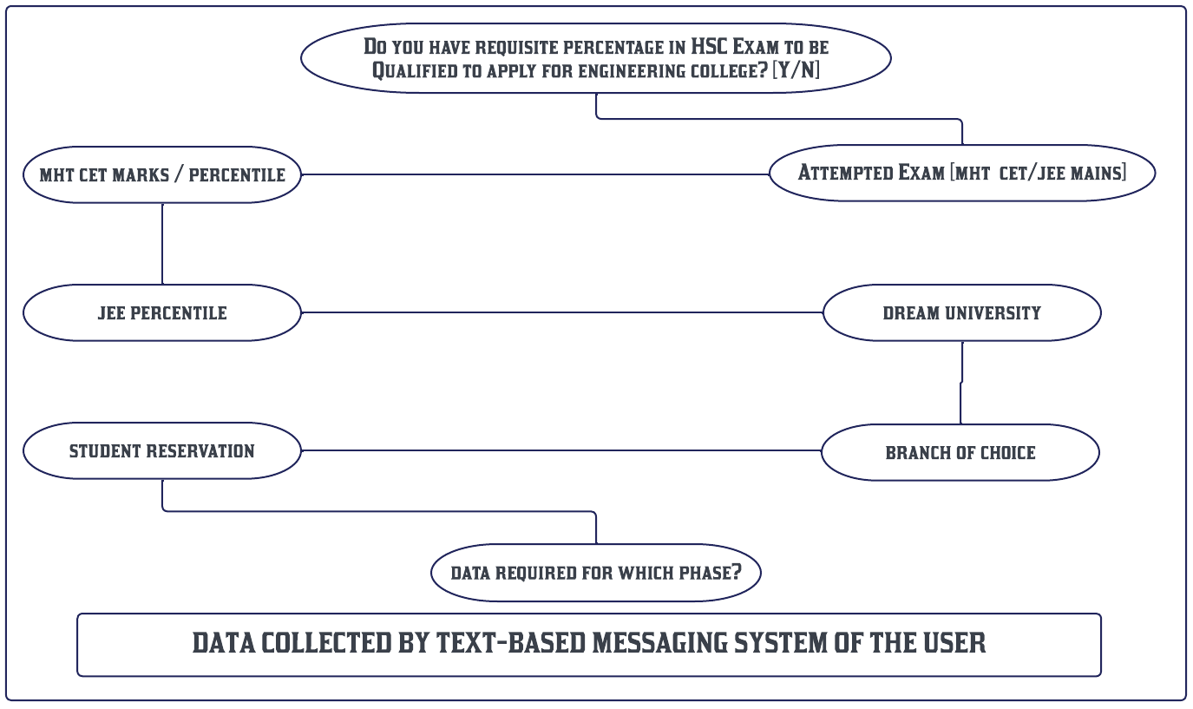

Our system will compare students' scores with college's cut-off and generate a list. The list will display the name of college, location, chances, cutoff range, branch, branch intake and official link of particular college.System also generates ratings based on users provided reviews. Our system will generate ratings using an efficient rating prediction algorithm. Simultaneously we will be working on the front-end and back-end of the system.

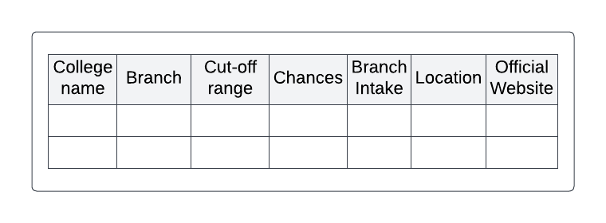

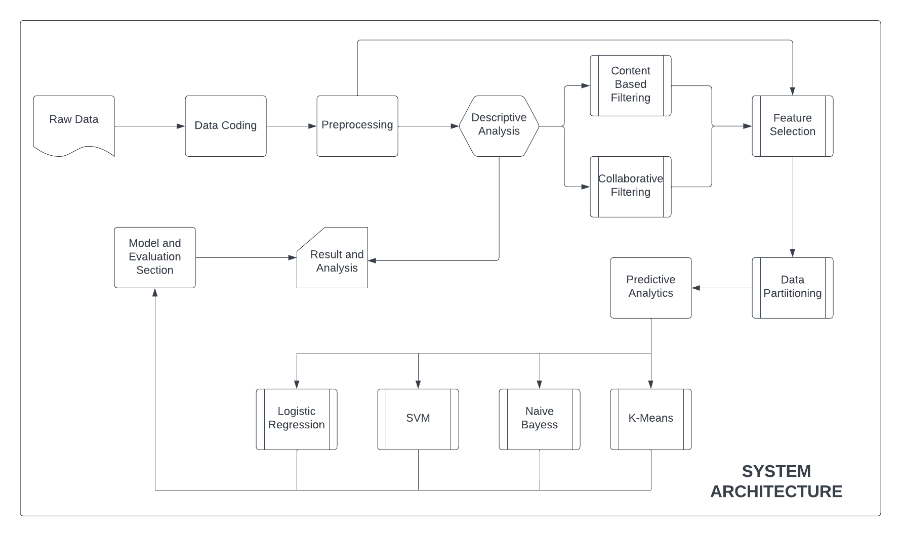

TECHNOLOGIES TO BE USED:-

* HTML and CSS:

The most basic form of web development includes designing page with the help of the most prominent and consistent web technology which not only contributes in designing the front end i.e. the web page in this case, but, also helps in organizing it with different forms of styles using CSS (cascading style sheets). HTML also allows developers to work along with other database applications that are necessary to store the details of the students.

* Python:

It is a general-purpose programming language designed to be used in a range of applications, including data science, software, automation as well as for web development.

The python code can be embedded into HTML code, or can be combined with various web template systems, and web frameworks. The web server will combine the results of the interpreted and executed Python code, which may be any type of data, including images, with the generated web page. This code may also be executed with a command-line interface (CLI) and can be used to implement standalone graphical applications.

It can also be used for Prediction via Machine Learning as Python libraries allow us to access, process, and transform our data.

ALGORITHMS TO BE USED:-

* COLLABORATIVE FILTERING:

It is a Machine Learning technique used to identify relationships between pieces of data. We will be using this technique in steps - Users similarity calculation (Pearson correlation, cosine similarity and Euclidean distance), Top N nearest neighbors’ selection and eventually Prediction.

So, in collaborative based filtering, the list of universities will be displayed on the basis of student’s CET and JEE percentile . It will compare the cut-off of the universities and on the basis of that the list of colleges will be listed with the user and system ratings.

* CONTENT BASED FILTERING

Recommendation to user is given only by the users individual behavior and data. First it analyzes the description of items preferred by user to decide the preferences that can be utilized to describe these items. based on users’ choices user profile is created, next each item attribute is compared with user profile so that only related items are recommended to the user. So in collaborative based the list of universities will be displayed on the basis of student’s CET and JEE percentile.

* K-MEANS:

Clustering algorithm tries to partition a set of data into a set of sub-clusters in order to discover meaningful groups that exist within them.Once clusters have been formed, the opinions of other users in a cluster can be averaged and used to make recommendations for individual users.

* NAIVE BAYES CLASSIFIER:

Bayes' Theorem-

Bayes' theorem is also known as Bayes' Rule or Bayes' law, which is used to determine the probability of a hypothesis with prior knowledge. It depends on the conditional probability. We will implement a Naive Bayes Algorithm using Python. Therefore we can easily compare the Naive Bayes model with the other models.

HARDWARE AND SOFTWARE REQUIREMENTS:

### Hardware Interface Requirements

* Processor speed of 0.5 Ghz or more for mobile gadgets
* Processor speed of 1.5ghz or more for desktop and computer gadgets
* Ram of 500mb and above for all devices
* Free storage memory capacity of more than 100mb

### Software Interface Requirements

* Windows/ android/ Linux/ mac/ chrome or any other operating system
* Mozilla Firefox / Google chrome / opera mini / UC browser or internet explorer

1. Development tools

* Ms-Excel/ Google sheets
* MySQL database
* Entity framework
* GitHub
* Google Colab
* Heroku

### 

### Communication Interface Requirements

* Internet connectivity

OBJECTIVES AND SCOPE:

The objectives of this system are:

* To help students to fill their preferences at the time of option-entry process accurately and to help make better choices of college before allotment.
* Whatever may be the scores, this application will help to find the best colleges for their desired branches. Hence, our proposed computer aided system will help the students to get the list of all colleges in which they could get the admission at the click of a button.
* The list will include colleges in which student has at least 50% of chance getting placed.
* The list will also provide link of respective college websites, so that you can surf them directly.
* The system will be designed with the use of different machine learning algorithms to come up with a good recommendation and predictor system.

The scopes of this system are:

* This system will be recommend colleges and that will predict chances of admit to the students to pursue their higher studies so that they will get clear idea where they can do progress or which factor like MHT-CET or JEE is imp. And this system will be useful for High School students.
* The systems available do not consider a lot of parameters, so this system can easily help students for getting appropriate guidance and also check where they can stand.
* The idea if successfully implemented, then can be used to predict cutoff and recommend colleges for various other fields of eduction.

REFERENCES:

[1]Prof. Vishal R. Shinde, Miss. Anagha Bagul, Mr. Amit Gupta, Miss. Sneha Javeri , “Chatbot for college related FAQs”, International Journal for Research in Engineering Application & Management (IJREAM), Special Issue - iCreate - 2019

[2]Naveen Kumar M, Linga Chandar P C, Venkatesh Prasad A, Sumangali K, “Android Based Educational Chatbot for Visually Impaired People” , IEEE Dec 2016,International Conference on Computational Intelligence and Computing Research (ICCIC)

[3]B. R. Ranoliya, N. Raghuwanshi, and S. Singh, "Chabot for university-related FAQs," 2017 International Conference on Advances in Computing, Communications, and Informatics (ICACCI), Udupi, 2017, pp. 1525-1530.

[4] P. R. Telang, A. K. Kali, M. Vukovic, R. Pandita and M. P. Singh, "A Conceptual Framework for Engineering Chatbots," in IEEE Internet Computing, vol. 22, no. 6, pp. 54-59, 1 Nov. -Dec. 2018.

[5] Emil Babu, Geethu Wilson, Msc Scholar, Assistant Professor, “ Chatbot For College Enquiry”, International Journal of Creative Research Thoughts (IJCRT), Vol-9, Issue 3, March 2021

[6]Dr. Arunakumari B.N, Vishnu Sastry H.K, Sheetal Neeraj, Shashidhar R,“An Automated Prediction Model For College Admission System” , Elementary Education Online, 2021; Vol 20 (Issue 6): pp. 1172-1180

[7]Varsha Powar, Sheetal Girase, Debajyoti Mukhopadhyay, Anuja Jadhav, Shweta Khude, Shital Mandlik, “Analyzing recommendation of colleges for students using data mining techniques”, IEEE Xplore: 2018

[8] Zhenrong Zhang, ”Design of a Personalized Recommendation System for Ideological and Political Courses in Colleges and Universities Based on a Collaborative Filtering Algorithm” IEEE Xplore: 2022

[9] Abdul Majeed Inamdar; Tanmay Mhatre; Pravin Nadar; Supriya Joshi, “Personalized College Recommender and Cutoff Predictor for Direct Second Year Engineering”, IEEE Xplore: 2022